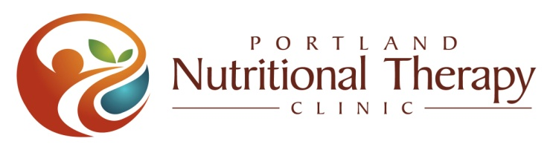
MENOPAUSE
Menopause should only mean: cessation of monthly bleeding!
Instead many women experience:

- hot flashes, night sweats
- weight gain
- fatigue
- loss of sex drive
- mood swings, brain fog
- brittle bones
- thinning hair, aging skin
- bladder issues, etc.

Nutritional Therapy can help you!

- Relieve underlying health issues that make menopause difficult

- Remove accumulated toxins

- Supply your body with building blocks for optimal health

- Incorporate nutrient-dense whole foods, to make you look and feel and younger

Let us guide you to find your way back to health
Free initial consultation & package deals available

Bio

Anja Middelveld 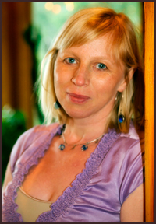

Nutritional Therapist, certified by NTA since 2009, Acupuncturist and Practitioner of Oriental Medicine since 2002, and Founder of Healing Path Holistic Medicine Clinic since 2004.
Nutrition was what first pulled me into natural medicine, and today I still belief that properly prepared nutrient dense food and digestion are the foundations to our health. We cannot obtain optimal health without addressing those foundations.
I found that Nutritional Therapy and Oriental Medicine work well together, as they share the belief of "no person is alike, and therefore each condition should be treated according to the bio-individuality of each person." My commitment to my own health is a large part of my inspiration and compassion to help others. I enjoy living in Corbett with my husband, daughter, dogs, and cat, as well as cooking whole foods, organic gardening, yoga, dancing, biking, and taking long walks in nature. I am honored to help you on your healing path.

Services (prices may vary from practitioner to practitioner):
- Free initial consultation (come and find out how nutritional therapy can help you, and meet your practitioner).
- One on one sessions with a therapist: initial & follow-ups
- Package deals are available, contact your practitioner to find out what they offer
- Classes (see event schedule)
- Shopping sessions

Detox/Cleansing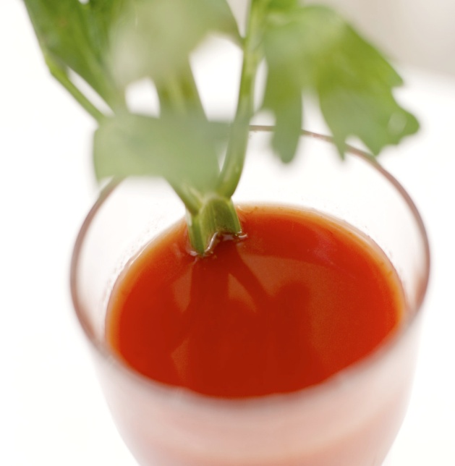

Every day, millions of molecules from different compounds enter our bodies through voluntary or involuntary ingestion. These chemicals come from foods, beverages, medicines, food additives, personal care, and numerous other sources. Excessive pollution in a system may result in malfunctioning or serious degeneration.

Every working system produces pollution as a result of normal functioning. Some of the pollutants produced within living systems are eliminated through naturally built-in processes.

No living system has the ability
to rid itself of all pollutants.

As a result, the system can slowly accumulate pollutants to a point of self-destruction. The human body has excellent built-in mechanisms to cleanse itself from pollutants, but the system is not perfect.

The advancement of science and industrialization, numerous foreign and toxic chemicals have been produced and released in living environments. These foreign chemicals are known as “xenobiotics.” Xenobiotics also include over-the-counter and prescription drugs. Numerous research scientists have demonstrated that xenobiotics are among the major causes of many acute and chronic health problems that have become widespread in Western society in recent decades. These compounds, if not cleared from the system, can interfere with normal biological processes and become hazardous to one’s health. The body’s accumulation of these toxic substances can produce a variety of distressful symptoms and medical conditions.

The poor nutritional habits of the Western world are due to the limited number of healthy foods being used in the daily diet. In addition, a variety of other factors related to our stressful modern life has increased the number of allergy problems tenfold in the last few decades. Most of the symptoms produced as a result of the accumulation of toxins are very similar to allergies. Mild toxicities and food allergies will produce very discomforting symptoms, such as poor digestion, gas, bloating, heartburn, headaches, fatigue, chronic mild infections, hormone imbalances, etc.

CLEAN PROGRAM
The basic premise of the Clean Program is that by creating the right conditions, our body will begin to naturally heal itself. How? Through removing the major toxins and adding in nutritionally-beneficial foods and perhaps some supplements depending on your needs.

You will start with an elimination diet, taking out the foods that make it more difficult to cleanse, and adding in foods that help cleanse. After 1-2 weeks on the elimination diet you may start your cleanse. The cleanse consists of 2 liquid meals a day, and 1 solid meal. Although we base our cleanse on Dr. Alejandro Junger’s book “Clean”, you are not required to purchase the kit of supplements they recommend, to ensure your success. We guide you through the cleanse process, and tailor it to your individual needs.

Schedule of events:

Feb 15th Clackamas Community College Health Fair
Feb 25th Women’s Expo Oregon Convention Center www.gogirlpdx.org find us at one of the tables
March 7th Lecture on Menopause at New Seasons/ Seven Corners
March 22nd Lecture on Menopause at New Seasons/ Happy Valley
April 2nd,

